**Experiment No: 1**

|  |
| --- |
| **Student Name and Roll Number: Kartavya Magoo** |
| **Semester /Section: FSA 1** |
| **Link to Code:** |
| **Date:** : 6th August 2021 |
| **Faculty Signature:** |
| **Marks:** |

|  |
| --- |
| **Objective(s):**  To familiarize the students to Linux interface. |
| **Outcome:**   * The students will understand commands used in Linux. |
| **Problem Statement:**  Implement the following things:   * Cygwin Installation * Basic Linux commands |
| **Background Study:**  Cygwin is a open source tool which provides that functionality of the Linux in windows Operating System. Cygwin is a large collection of GNU and Open Source tools which provide functionality similar to a [Linux distribution](https://en.wikipedia.org/wiki/Linux_distribution) on Windows. It is a DLL (cygwin1.dll) which provides substantial POSIX API functionality. |
| **Question Bank:**   1. **What is Linux?** 2. How will you List files from a directory? 3. How files in a directory can be removed? 4. How to find out a word in a file? 5. What are wildcards? |

**Student Work Area**

**Algorithm/Flowchart/Code/Sample Outputs**

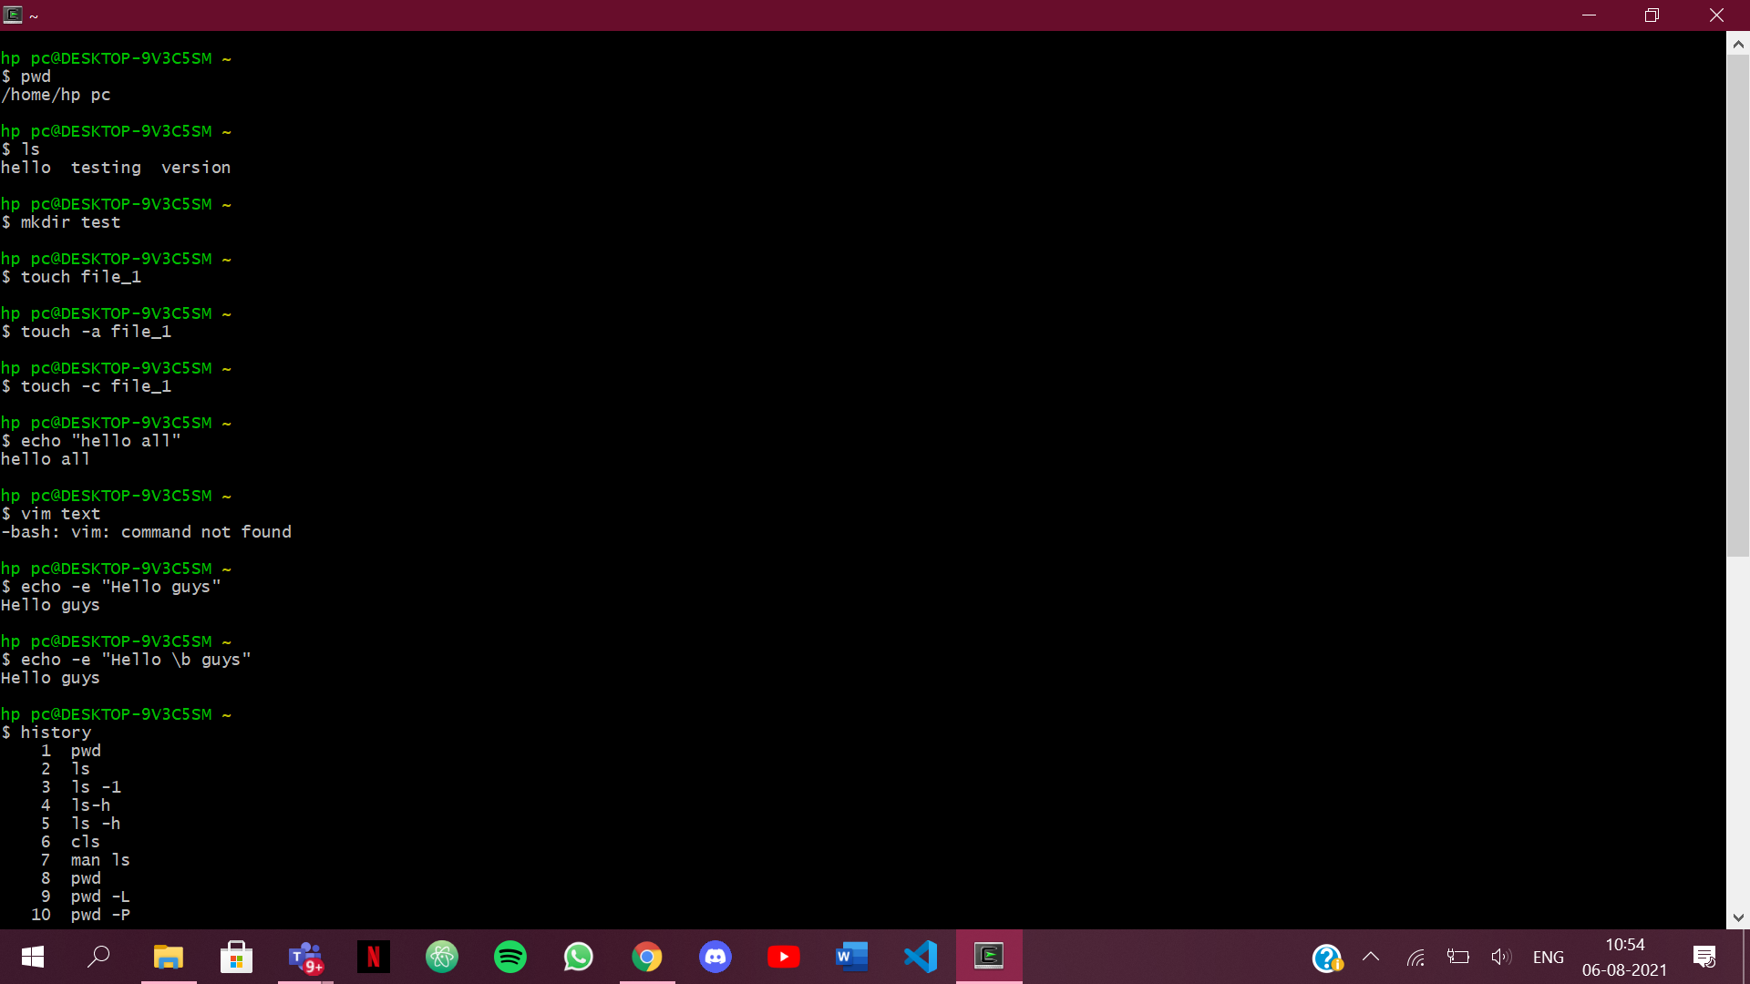

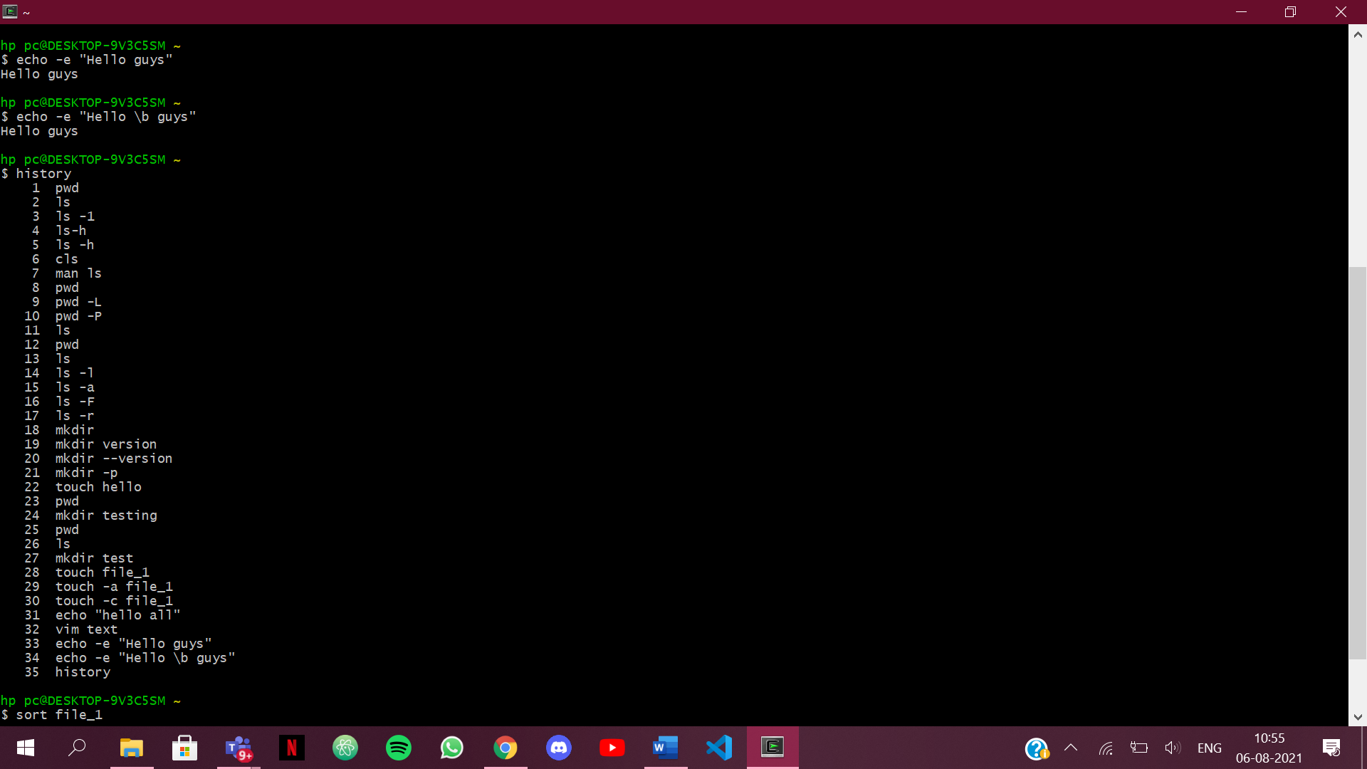

1. **What is Linux?**

Ans-1 Linux is an operating system or a kernel disturbed under an open source license.Its functionality is quite like UNIX. The kernel is a program at the heart of the Linux opearting system that takes care of fundamental stuff, like letting hardware communicate with software.

1. **How will you List files from a directory?**

Ans-2. We use ls command to display the contents of a directory. The ls command writes to standard output the contents of each specified directory or the name of each specified file,along with any other information you ask for with the flags.

1. **How files in a directory can be removed?**

Ans-3. To delete a single file ,we use rm(remove) command followed by the filename:

$ rm filename

To delete multiple files at once, use rm command followed by the file names seperated by space.

$ rm filename1 filename2 filename3

1. **How to find out a word in a file?**

Ans-4. Grep command is used to search for a string of characters in a specified file.the text search pattern is called regular expression.When it finds a match,it prints the line with the result.The grep command is handy when searching through large log file.

grep word filename

1. **What are wildcards?**

Ans-5. Wildcards are characters that indicate a command applies to all resources whose names match a specified character string.The asterik(*) wildcard tells the system to match zero or more specified characters,up to maximum length of the string.

**EXPERIMENT NO. 2**

|  |
| --- |
| **Student Name and Roll Number: Kartavya Magoo** |
| **Semester /Section: FSA 1** |
| **Link to Code:** |
| **Date:** 10th August 2021 |
| **Faculty Signature:** |
| **Marks:** |

|  |
| --- |
| **Objective:**  To write the shell programming code for the following. |
| **Outcome:**  Student is able to write code in shell programming |
| **Problem Statement:**  a) Write A Shell Program of Hello World  b) Write a shell program to find factorial of a number.  c) Write a shell program to find gross salary of an employee.  d) Write a shell program to display the menu and execute instructions accordingly  **(i)**List of files **(ii)**Process Status **(iii)** Date **(iv)** users in program **(v)** Quit |
| **Background Study:**  A shell script is a file with a set of commands in it. The shell reads this file and executes the instructions as if they were input directly on the command line.  A shell is a command-line interpreter and operations such as file manipulation, program execution and text printing is performed by shell script. So, we will use vi editor to edit our files. |
| **Question Bank:**   1. What is a shell? 2. What is the significance of $#? 3. What are the different types of commonly used shells on a typical Linux system? 4. How will you pass and access arguments to a script in Linux? 5. Use sed command to replace the content of the file (emulate tac command) |

**Student Work Area**

**Algorithm/Flowchart/Code/Sample Outputs**

Q1. Hello World

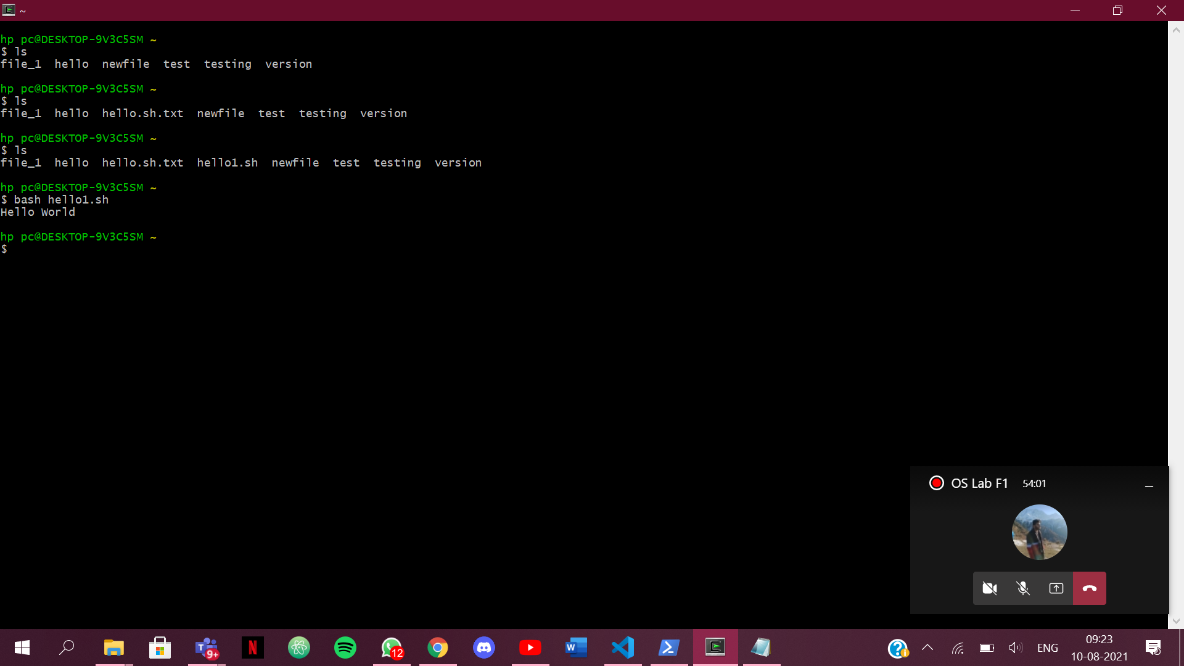

Q2. Factorial 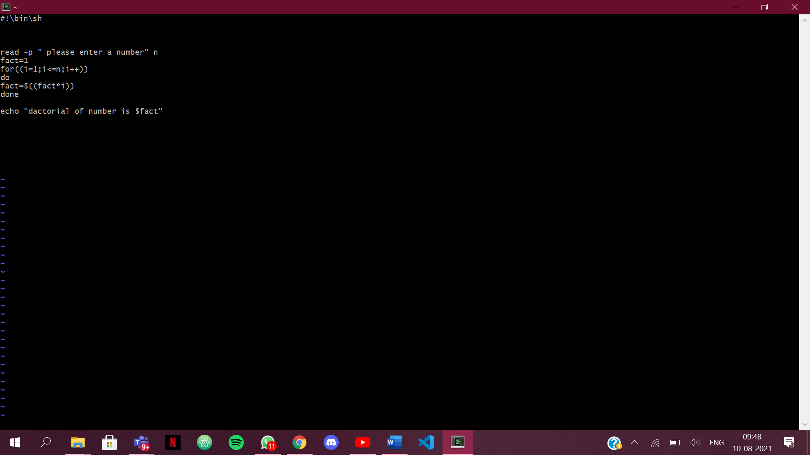

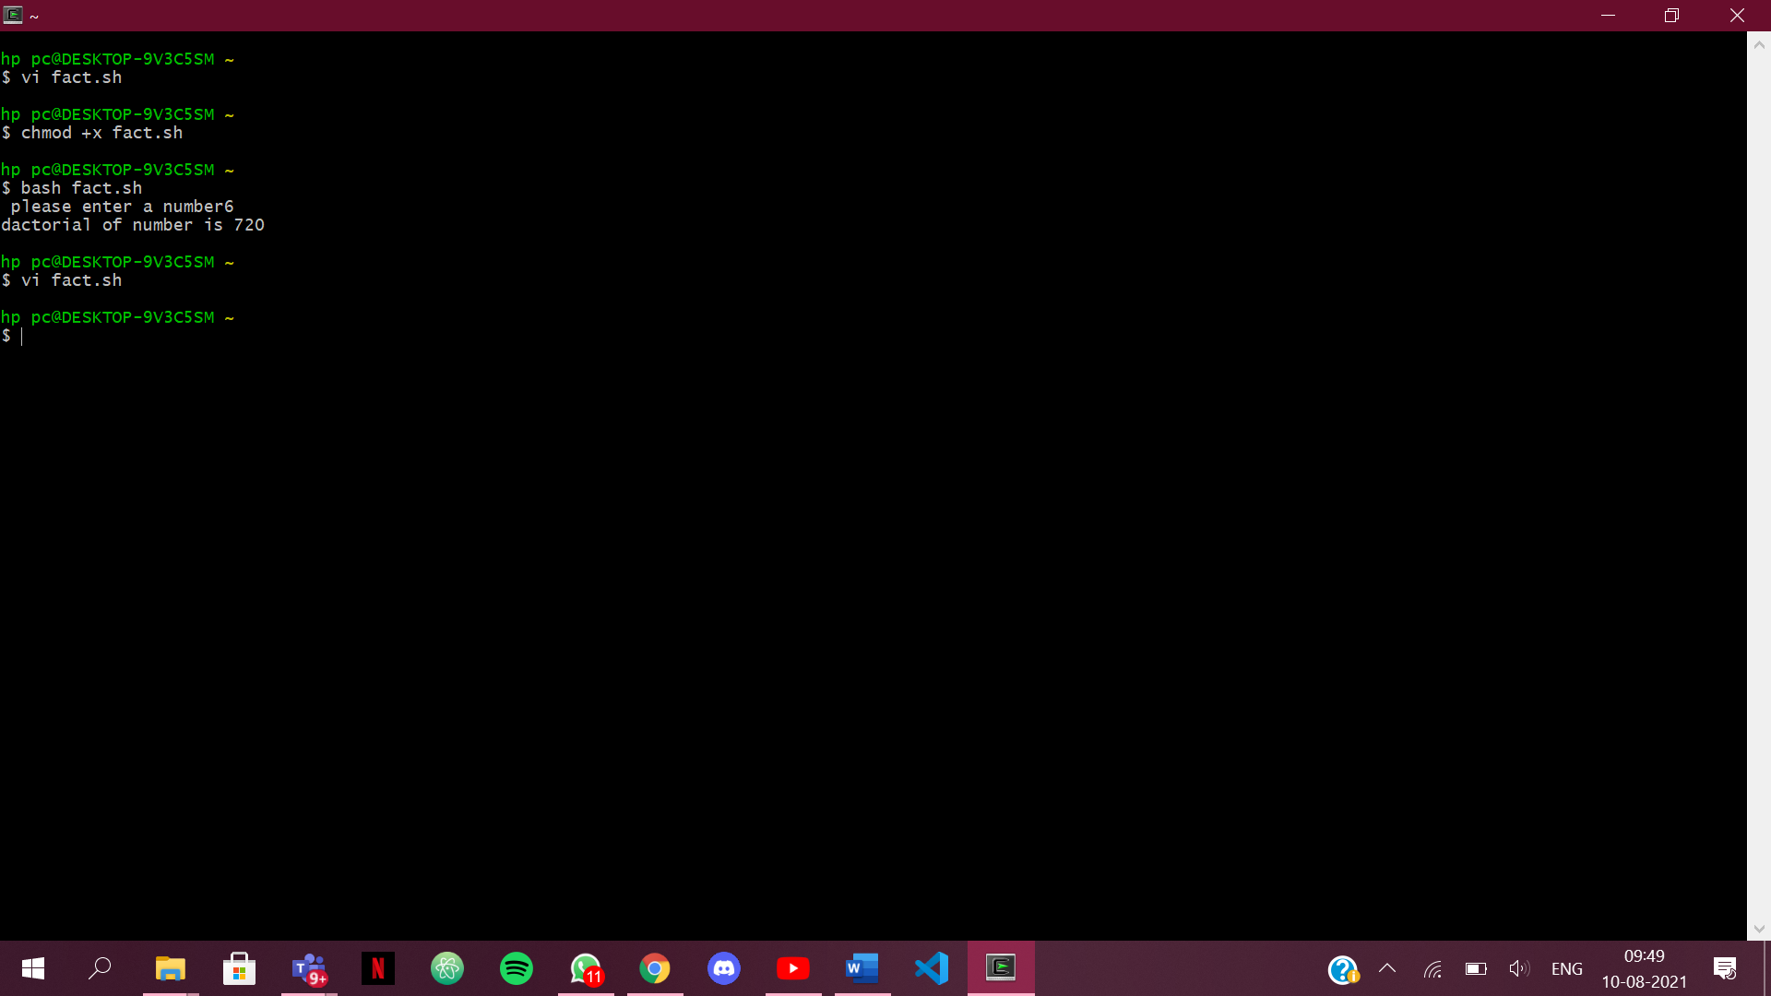

1. Gross salary

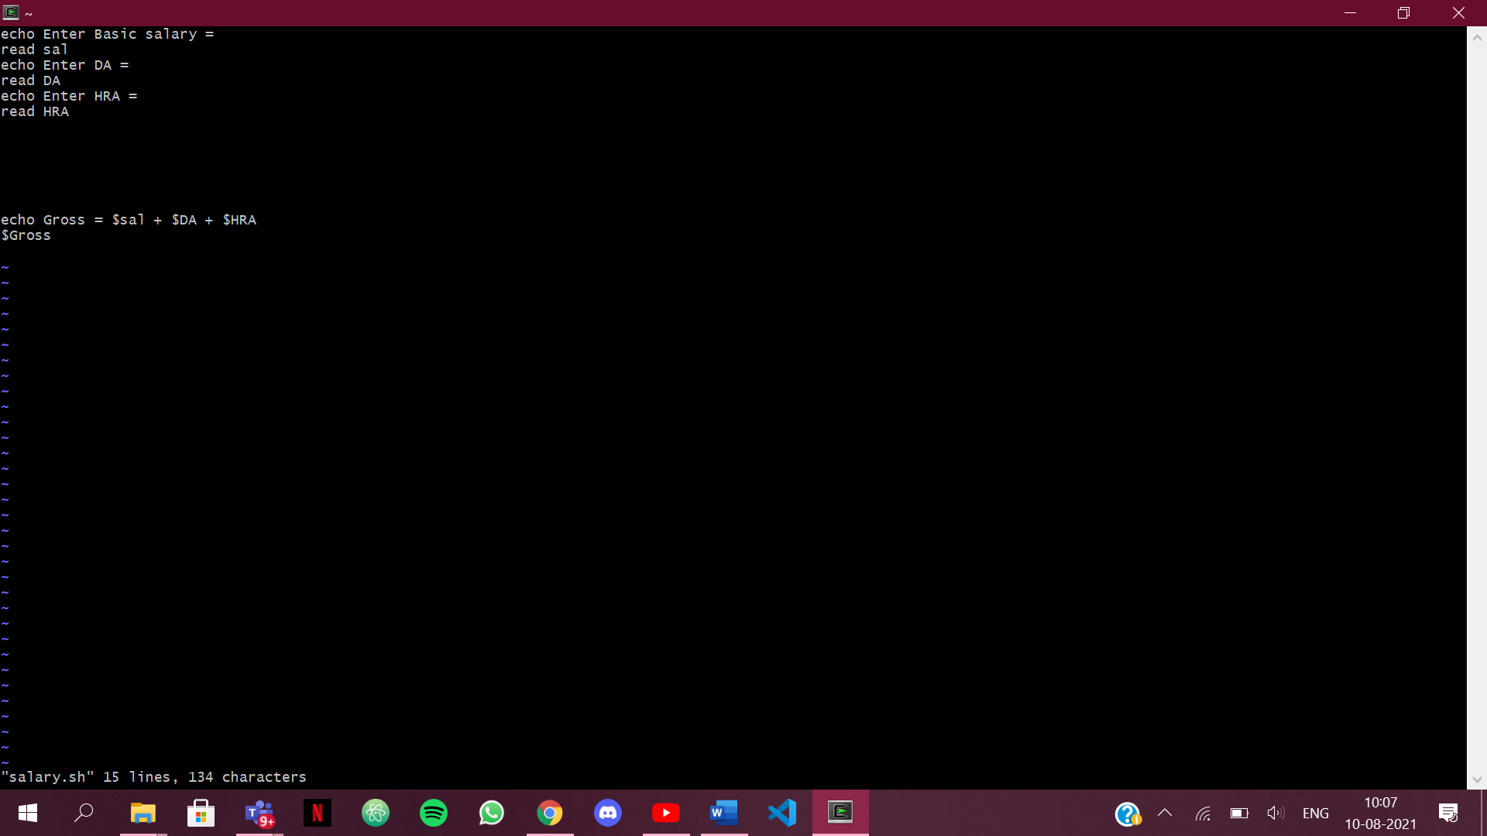

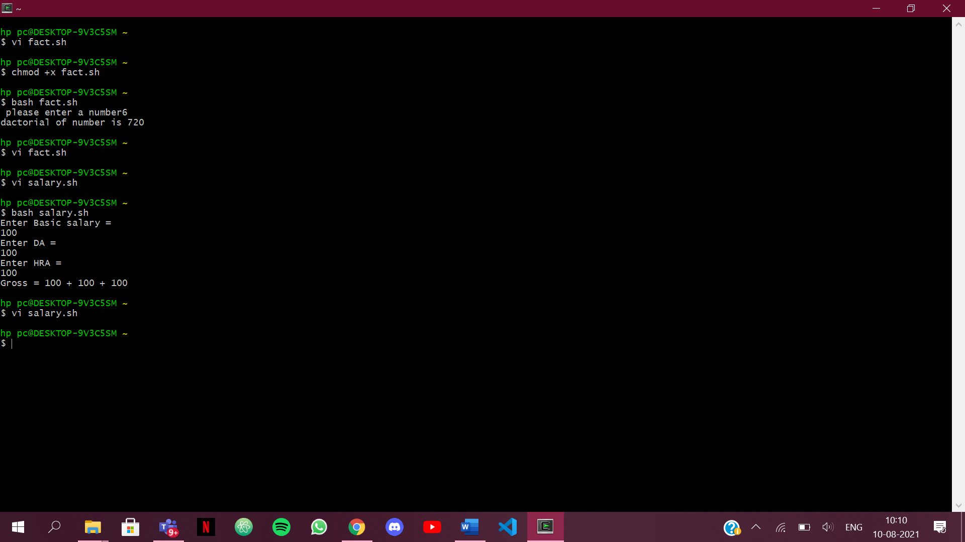

1. List

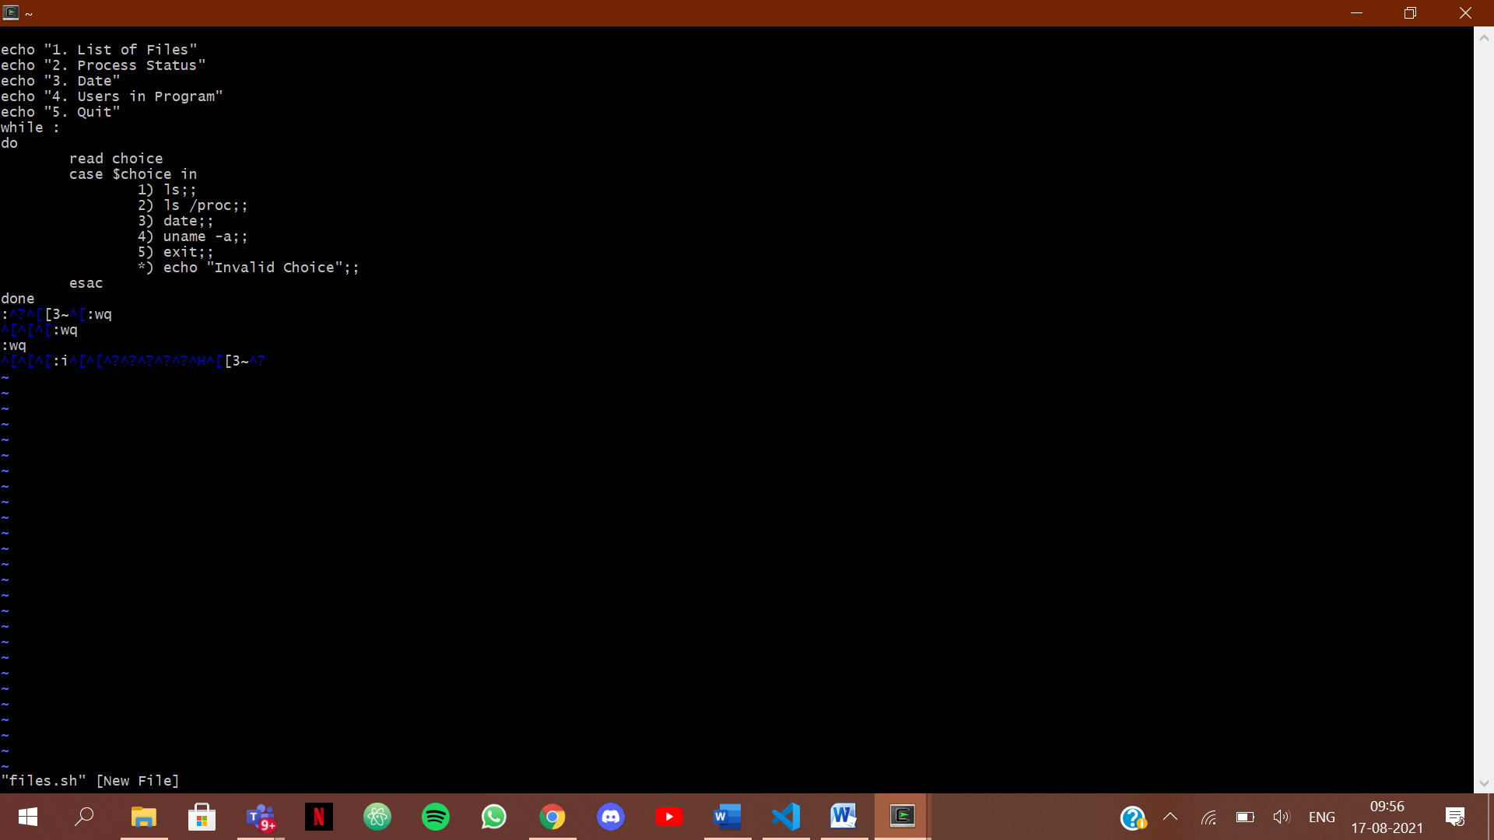

1. **What is a shell?**

Ans-1. A shell is an interface between the user and the kernel .Even though there can be only one kernel, a system can have many shell running simultaneously. So, whenever a user enters a command through the keyboard, the shell communicates with the kernel to execute it and then display the output to the user.

1. **What is the significance of $#?**

Ans-2. The significance of $# is that it shows the count of arguments passed to the script.

1. **What are the different types of commonly used shells on a typical Linux system?**

Ans-3. csh,ksh,bash,Bourne. The most commonly used and advanced shell used today is “Bash”.

1. **How will you pass and access arguments to a script in Linux?**

Ans-4. Arguments can be passed as: scriptName “Arg1” “Arg2”….”Argn” and can be acessed inside the script as $1,$2…$n.

1. **Use sed command to replace the content of the file (emulate tac command)**

Ans-5. If cat file1

GHIJ

KLMN

Then the output should be:

KLMN

GHIJ

sed ‘1! G; h;$!d’ file1

Here G command appends pattern to the space,h command copies pattern buffer to hold buffer and d command deletes the current pattern space.

**EXPERIMENT NO. 3**

|  |
| --- |
| **Student Name and Roll Number: Kartavya Magoo** |
| **Semester /Section: FSA 1** |
| **Link to Code:** |
| **Date:** 17th August 2021 |
| **Faculty Signature:** |
| **Marks:** |

|  |
| --- |
| **Objective:**  To write the shell programming code for the following. |
| **Outcome:**  Student is able to write code in shell programming |
| **Problem Statement:**  a) Write a shell program to find Fibonacci series.  b) Write a shell program to find largest of three numbers.  c) Write a shell program to find average of N numbers |
| **Background Study:**  A shell script is a file with a set of commands in it. The shell reads this file and executes the instructions as if they were input directly on the command line.  A shell is a command-line interpreter and operations such as file manipulation, program execution and text printing is performed by shell script. So, we will use vi editor to edit our files. |
| **Question Bank:**   1. How to use multi line comments in shell script? 2. What is the difference between soft and hard links? 3. Explain about loops and what are the loops available in LINUX? 4. What are absolute and relative paths. 5. How to debug a shell script. |

**Student Work Area**

**Algorithm/Flowchart/Code/Sample Outputs**

1. Fibonacci Series

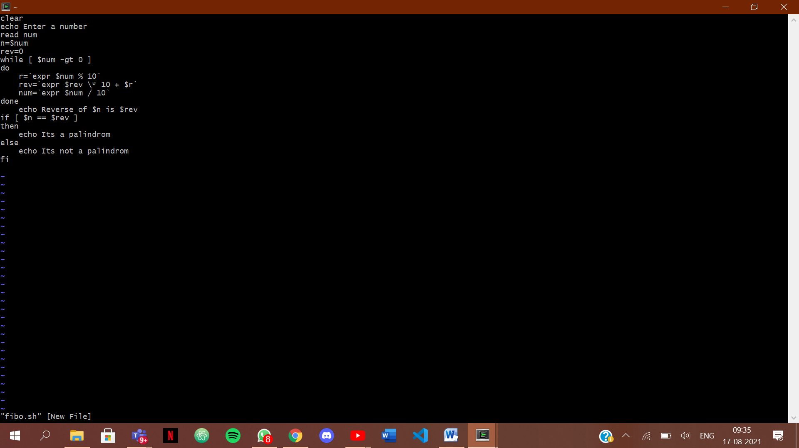

1. Greatest of 3 numbers 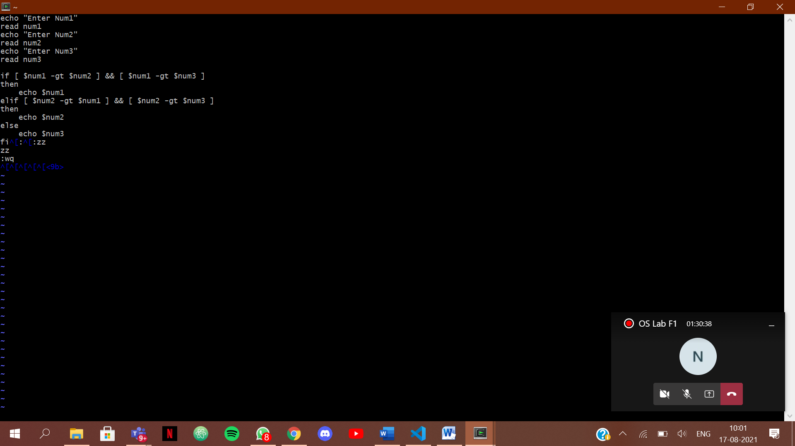
2. Average

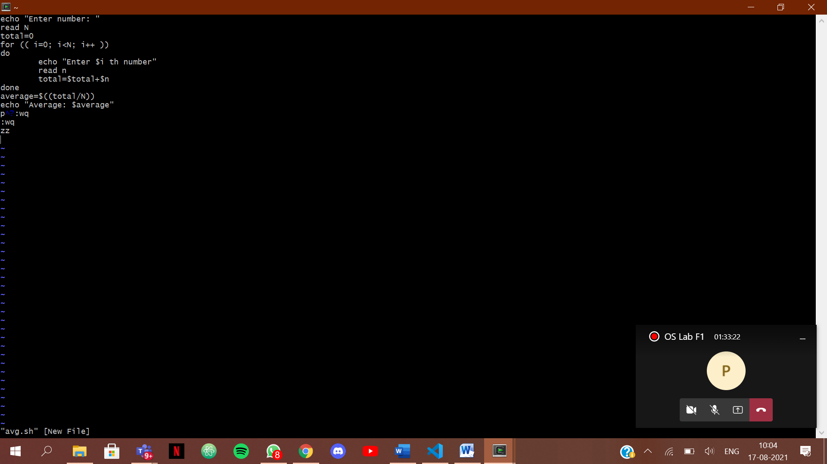

**QUESTION BANK ANSWERS**

**1.** In shell or bash shell, we can comment on multiple lines using << and name of comment**.**

**2. What is the difference between soft and hard links?**

**Ans -** Hard Links cannot be used across file systems whereas soft links can be used across file systems.

**3. Explain about loops and what are the loops available in LINUX?**

**Ans -**

The while loop

The for loop

The until loop

The select loop

**4. What are absolute and relative paths?**

**Ans -** An absolute path always contains the root element and the complete directory list required to

locate the file.

A relative path needs to be combined with another path in order to access a file.

**EXPERIMENT NO. 4**

|  |
| --- |
| **Student Name and Roll Number:** Kartavya Magoo |
| **Semester /Section:** 5th/FSA1 |
| **Link to Code:** |
| **Date:** 24th August 2021 |
| **Faculty Signature:** |
| **Marks:** |

|  |
| --- |
| **Objective:**  To write the shell programming code for the following. |
| **Outcome:**  Student is able to write code in shell programming |
| **Problem Statement:**  a) Write a shell program to check whether a number is even or odd  b) Write a shell program to find whether a number is prime or not.  c) Write a shell program to find whether a number is palindrome or not.  d) Write a shell program to type number 1 to 7 and then print its corresponding day of week |
| **Background Study:**    A shell script is a file with a set of commands in it. The shell reads this file and executes the instructions as if they were input directly on the command line.  A shell is a command-line interpreter and operations such as file manipulation, program execution and text printing is performed by shell script. So, we will use vi editor to edit our files. |
| **Question Bank:**   1. What is a shell? 2. What is the significance of $#? 3. What are the different types of commonly used shells on a typical Linux system? 4. How will you pass and access arguments to a script in Linux? 5. Use sed command to replace the content of the file (emulate tac command) |

**Student Work Area**

**Algorithm/Flowchart/Code/Sample Outputs**

1. Even Odd

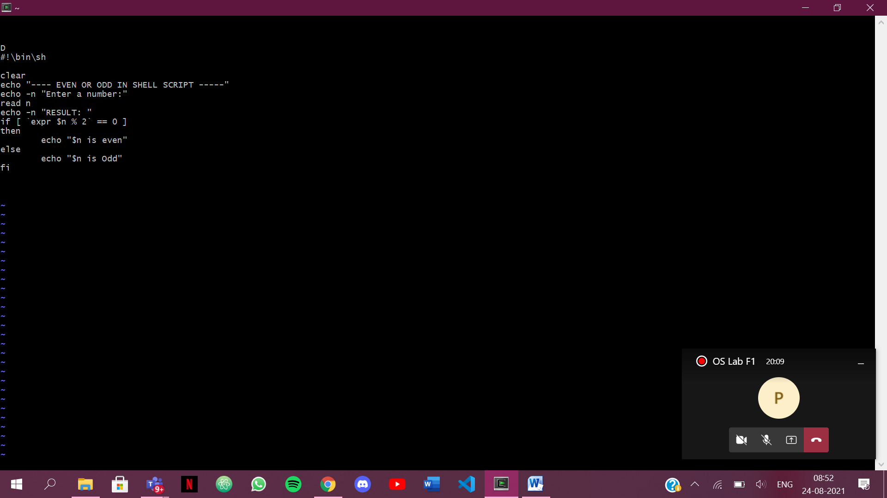

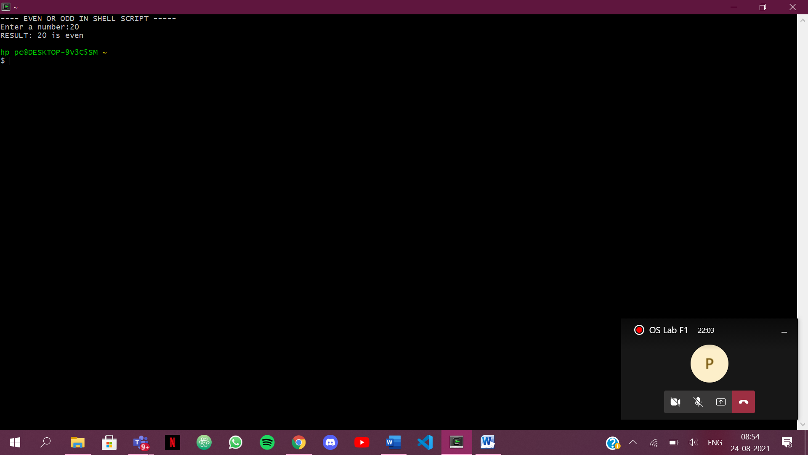

1. Palindrome

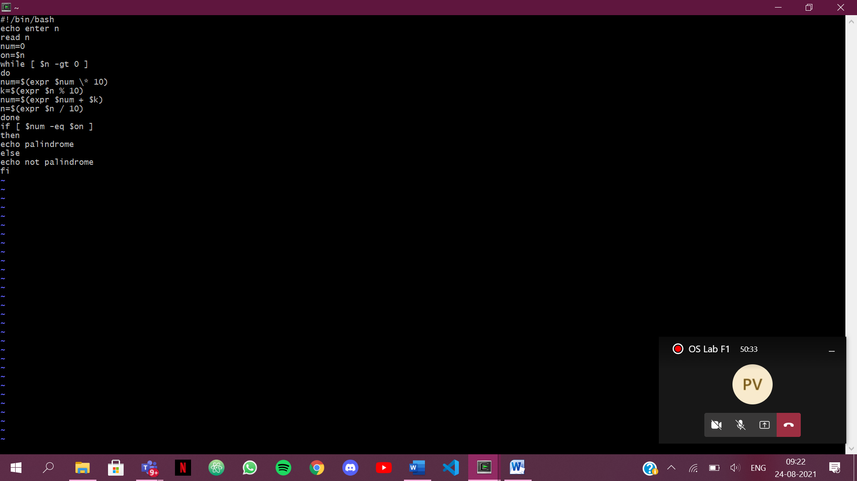

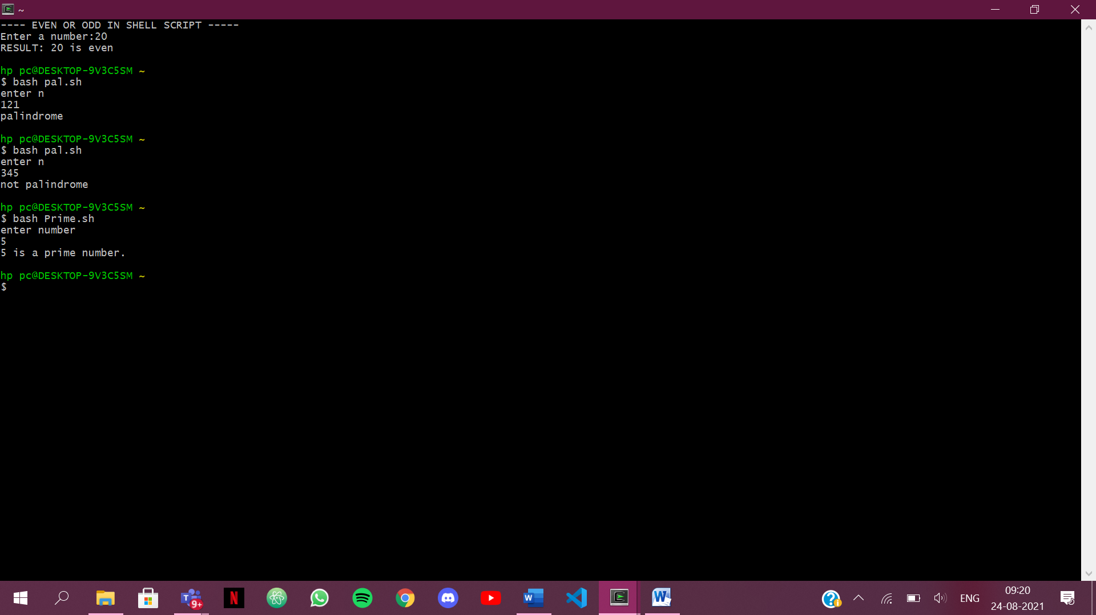

1. Prime Number

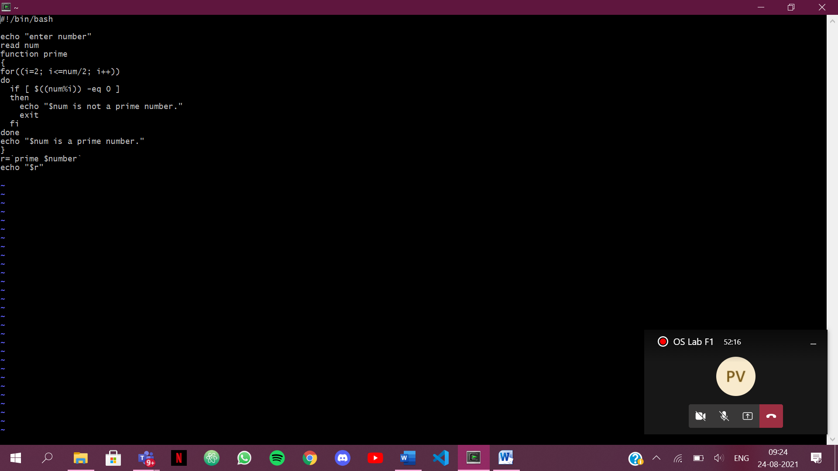



1. Weekdays

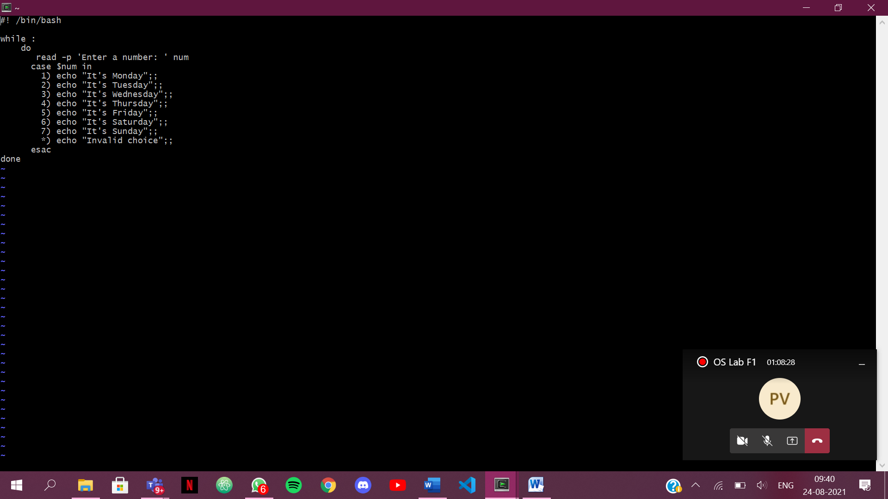

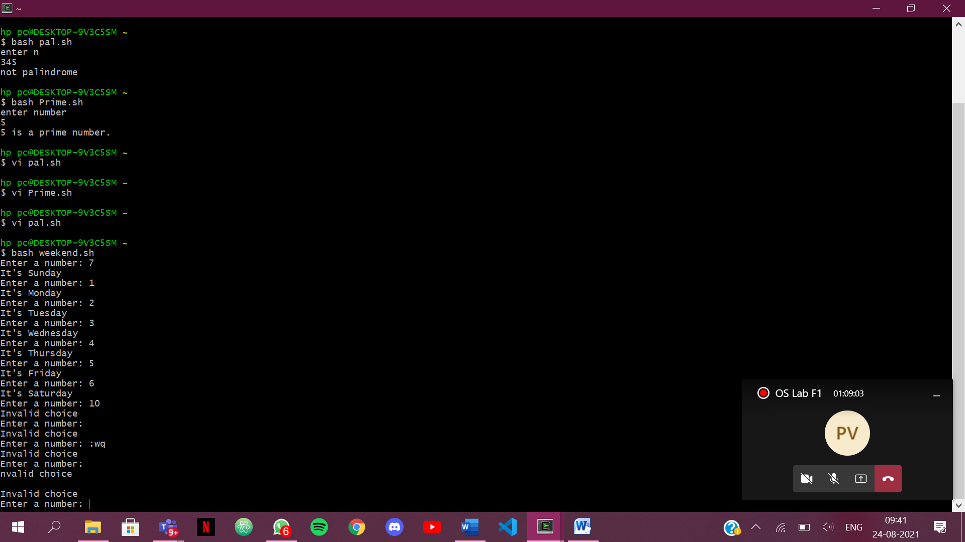

**QUESTION BANK ANSWERS**

1.What are Zombie Process?

Ans - A zombie process is a process whose execution is completed but it still has an entry in the

process table.

2. What are different types of variables used in shell script?

Ans - System-Defined Variables.

User-Defined Variables.

3. What are the different types of modes available in Vi editor?

Ans - Command Mode , Entry Mode And Last Line Mode

4. What are the different types of permission at file level in shell?

Ans - Execute Permission

Write Permission

Write and execute permission.

Read Permission

5. How to use comments in shell script.

Ans - By Using #

**Experiment No: 5**

|  |
| --- |
| **Student Name and Roll Number:** Kartavya Magoo |
| **Semester /Section:** 5th semester/ FSA-1 |
| **Link to Code:** |
| **Date**: 31st August 2021 |
| **Faculty Signature:** |
| **Marks:** |

|  |
| --- |
| **Objective:**  Write a program to implement CPU scheduling for first come first serve approach. |
| **Outcome:**  The students will understand the First-cum-first-serve algorithm |
| **Problem Statement:**  Implement the following CPU scheduling Algorithms.   1. FCFS with Arrival time 2. FCFS without Arrival time |
| **Background Study:**  **FCFS**   * The simplest CPU-scheduling algorithm is the first-come, first-served (FCFS) scheduling algorithm. With this algorithm, processes are assigned the CPU in the order they request it. * There is a single queue of ready processes. * The implementation of the FCFS policy is easily managed with a FIFO queue. When a process enters the ready queue, its PCB is linked onto the tail of the queue. * The average waiting time under the FCFS policy, however, is often quite long. |
| **Question Bank:**   1. Which module gives control of the CPU to the process selected by the short-term scheduler?    1. **dispatche**r    2. interrupt    3. scheduler    4. none of the mentioned 2. The processes that are residing in main memory and are ready and waiting to execute are kept on a list called    1. job queue    2. **ready queue**    3. execution queue    4. process queue 3. The interval from the time of submission of a process to the time of completion is termed as    1. waiting time    2. **turnaround time**    3. response time    4. throughput 4. Which scheduling algorithm allocates the CPU first to the process that requests the CPU first?    1. **first-come, first-served scheduling**    2. shortest job scheduling    3. priority scheduling    4. none of the mentioned 5. In priority scheduling algorithm    1. **CPU is allocated to the process with highest priority**    2. CPU is allocated to the process with lowest priority    3. equal priority processes cannot be scheduled    4. none of the mentioned |

**Student Work Area**

**Algorithm/Flowchart/Code/Sample Outputs**

CODE : 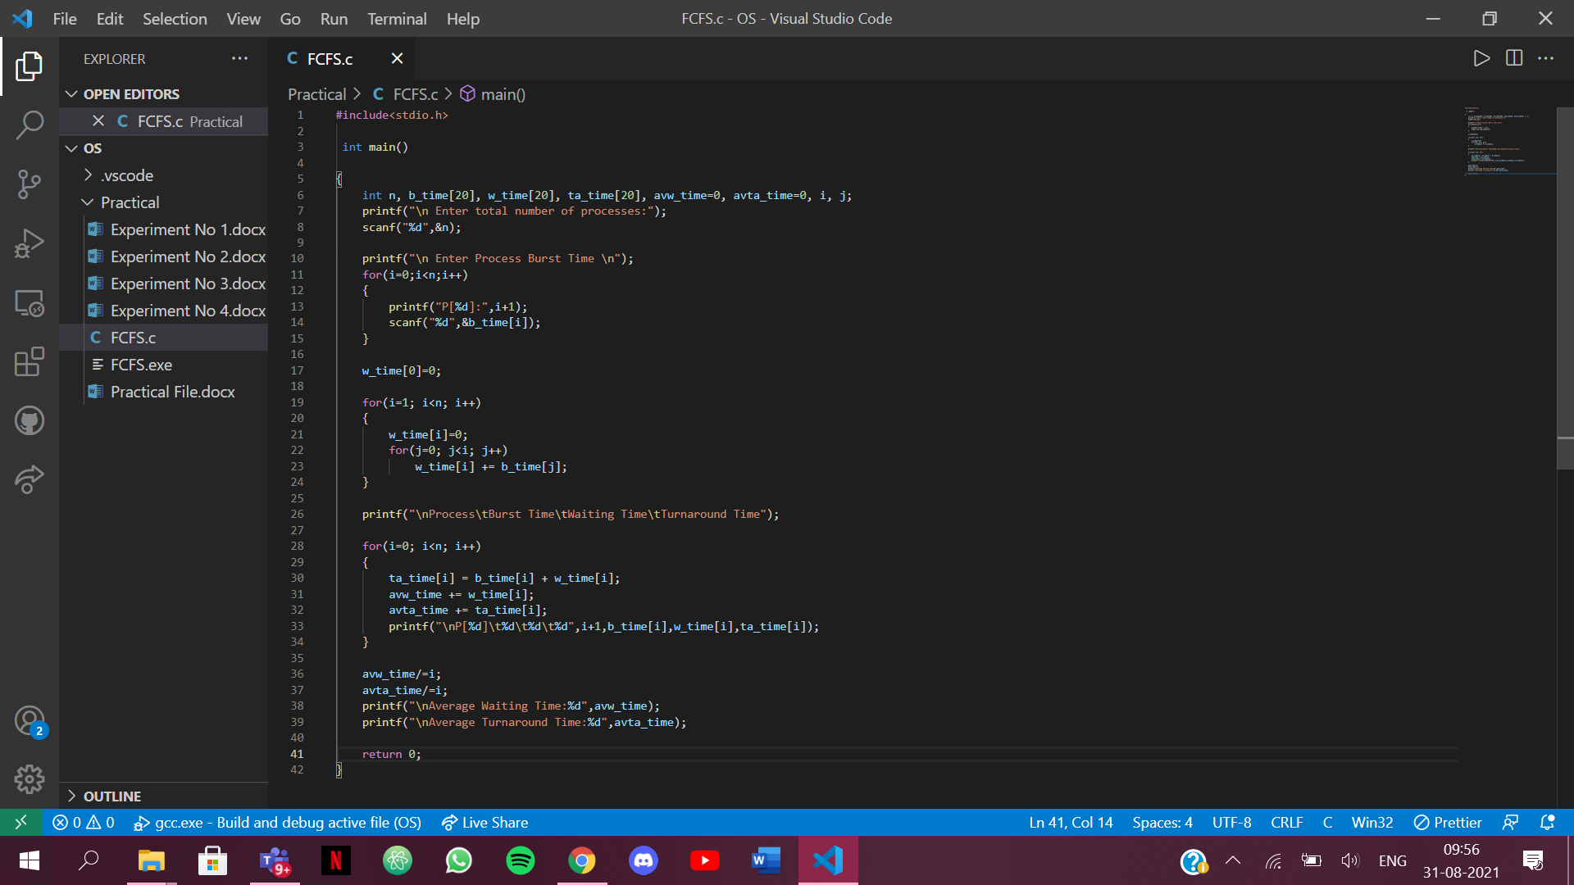

OUTPUT:

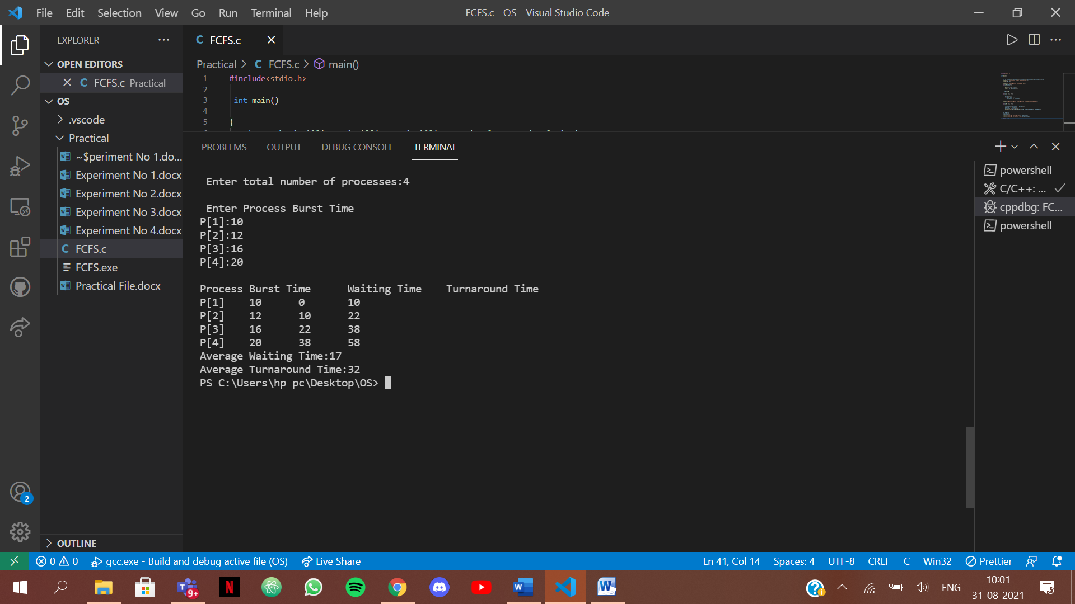

**Experiment No: 6**

|  |
| --- |
| **Student Name and Roll Number:** Kartavya Magoo |
| **Semester /Section:** 5th semester/ FSA-1 |
| **Link to Code:** |
| **Date**: 8th September 2021 |
| **Faculty Signature:** |
| **Marks:** |

|  |
| --- |
| **Objective:**  Write a program to implement CPU scheduling for shortest job first (Preemptive and Non-Preemptive) |
| **Outcome:**  The students will understand the Shortest Job First scheduling mechanism |
| **Problem Statement:**  Implement the following CPU scheduling Algorithms.   * SJF (Non-Preemptive) * SJTF (shortest remaining time first -Preemptive SJF) |
| **Background Study:**   * Shortest Job first is having the advantage of a minimum average waiting time . * This algorithm associates with each process the length of the process next burst time.When CPU is available it assigned to the process that has the smallest next CPU burst time.if CPU burst time of two process is same then it follows FCFS. * It may cause starvation if shorter processes keep coming. This problem can be solved using the concept of ageing. * It is practically infeasible as Operating System may not know burst time and therefore may not sort them. |
| **Question Bank:**   1. [Scheduling algorithm](https://t4tutorials.com/round-robin-process-scheduling-algorithm-in-operating-systems/) In multilevel feedback A. processes are not classified into groups B. a process can move to a different classified ready queue… C. classification of the ready queue is permanent D. none of the mentioned 2. Select one which algorithms tend to minimize the process flow time? A. First come First served B. Earliest Deadline First C. Shortest Job First D. Longest Job First 3. The process can be classified into many groups in A. [shortest job scheduling algorithm](https://t4tutorials.com/shortest-job-first-scheduling-sjf-process-scheduling-in-operating-systems/) B. multilevel queue scheduling algorithm C. round-robin scheduling algorithm D. priority scheduling algorithm 4. The turnaround time for short jobs during multiprogramming is usually Shortened and that for long jobs is slightly ___________ A. Shortened B. Unchanged C. Lengthened D. Shortened 5. Time quantum can be said A. multilevel queue scheduling algorithm B. round-robin scheduling algorithm C. shortest job scheduling algorithm D. priority scheduling algorithm |

**Student Work Area**

**Algorithm/Flowchart/Code/Sample Outputs**

1. SJF (Pre-emptive)

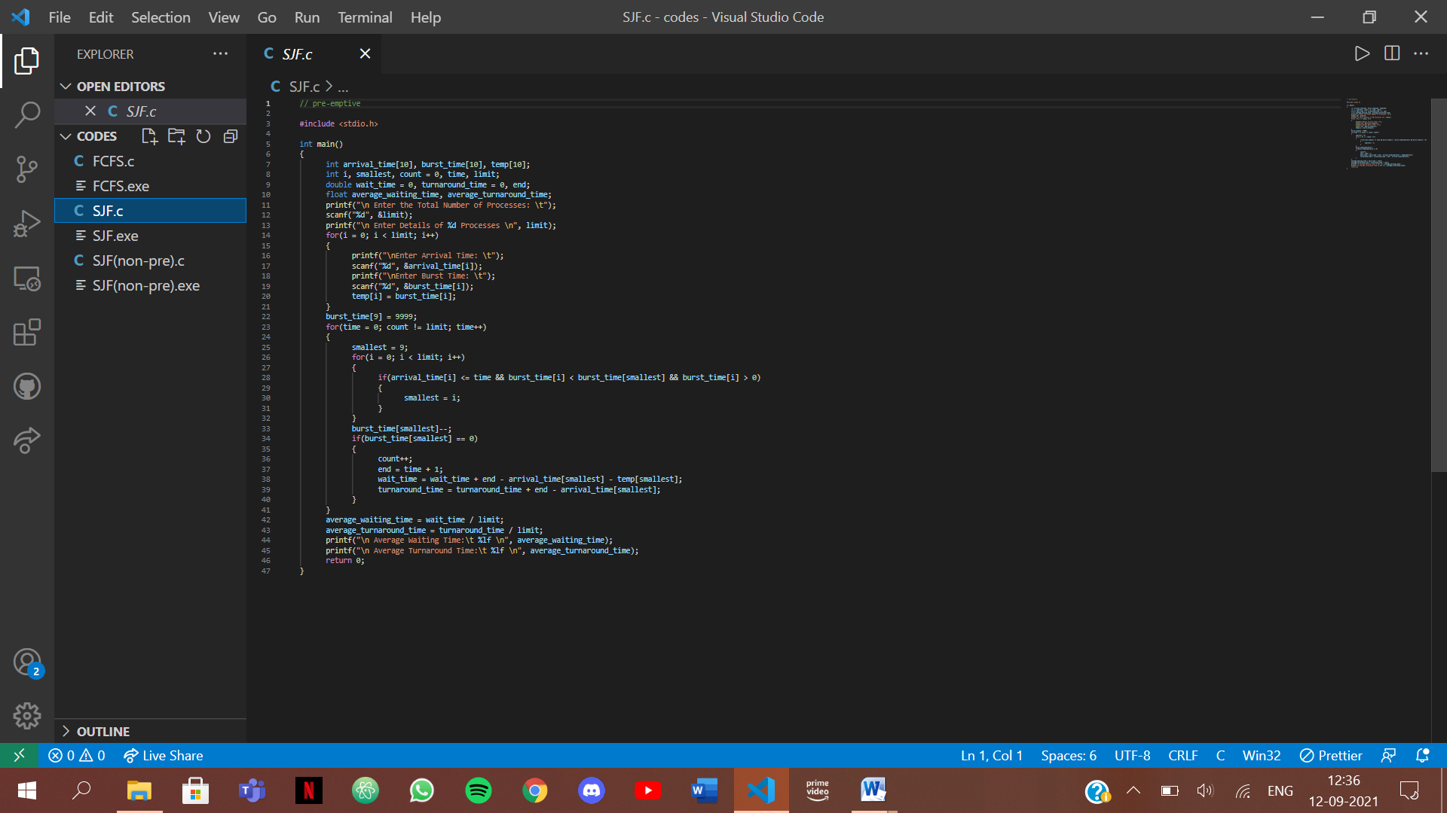

Output:

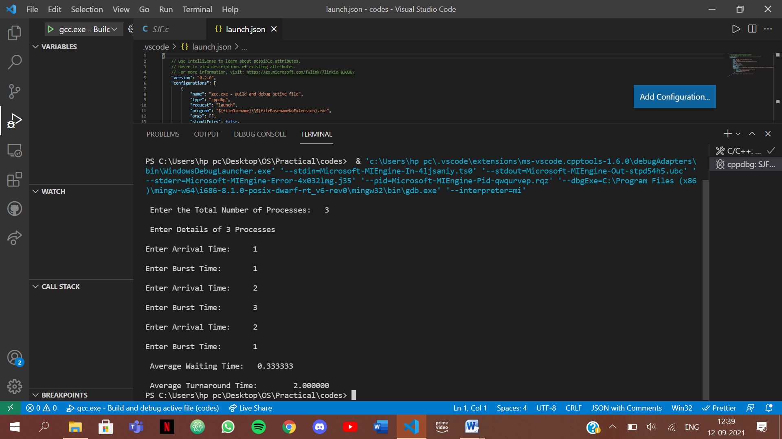

1. SJF (Non Pre-emptiv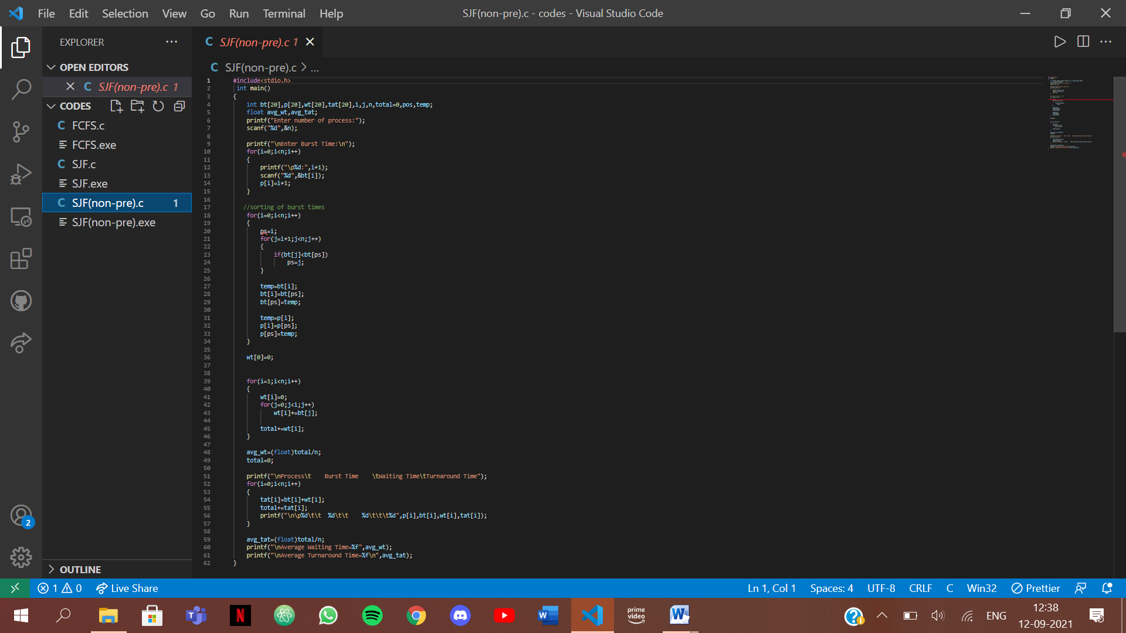

Output:

